LAB 1: ADOBE ANIMATE
Introduction
Adobe Animate is a versatile multimedia authoring and animation software developed by Adobe Inc., renowned for its ability to create dynamic and interactive animations across a wide range of platforms, including web, mobile, and television. Whether designing animated banners,
interactive games, or sophisticated vector animations, Adobe Animate provides a comprehensive suite of tools that cater to both beginners and seasoned animators alike. With features such as
vector drawing, character rigging, and asset warping, it has become an essential tool in the animation and multimedia industry.
This lab is designed to introduce you to the fundamental features of Adobe Animate, equipping you with the basic skills necessary to begin creating your own animations. Throughout this lab, you will explore how to effectively navigate the Animate workspace, which is essential for
streamlining your workflow and maximizing efficiency. You will also learn how to create and manipulate motion tweens, a core technique for producing smooth and realistic animations.
Additionally, the lab will cover working with symbols, an integral part of the animation process in Adobe Animate. Symbols allow for efficient reuse of assets and contribute to a more organized project structure. Managing layers will also be a key focus, enabling you to control the depth and complexity of your animations with precision.
By mastering these foundational skills, you will be well-prepared to utilize Adobe Animate in your creative endeavors. Whether your goal is to produce professional-quality animations or simply explore the possibilities of multimedia content creation, this lab will provide you with the tools and knowledge needed to bring your ideas to life.

Objectives
The main objectives of this lab are:
-Setting Up Adobe Animate: Installing Adobe Animate.
-Getting Familiar with the Workspace: Understanding the toolbar, properties panel, timeline, and stage.
-Learning Basic Tools and Functions: Mastering the selection, drawing, shape, and editing tools.
-Exploring Shape Tween: Creating shape tweens and morphing objects into different shapes.
-Working with Symbols: Understanding the creation and manipulation of symbols.
Creating Motion Tweens: Learning how to animate objects using motion tweens.

-Managing Layers: Organizing and utilizing layers effectively in animation projects.
-Exporting Animations: Exporting completed animations in various formats for different platforms.

Setting Up Adobe Animate
- Visit the Adobe Website:
  - Go to the Adobe Animate page.
  - Click "Free Trial" or "Buy Now" to download the latest version.

Download and Install:
  - Sign in with your Adobe ID or create a new one if needed.
  - Download the installer file and open it.
  - Follow the on-screen instructions to complete the installation.

Launch and Sign In:
  - Once installed, launch Adobe Animate.
  - Sign in with your Adobe ID when prompted.
  - You're now ready to start creating animations with Adobe Animate!
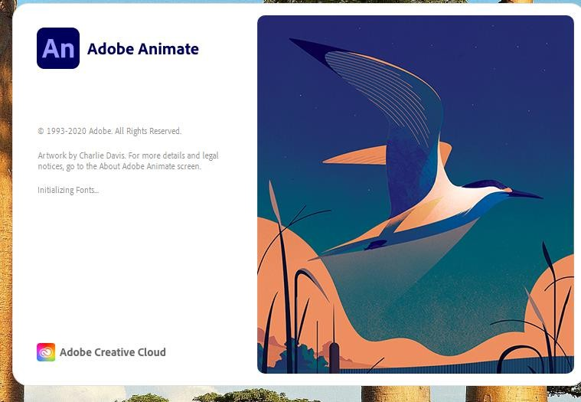

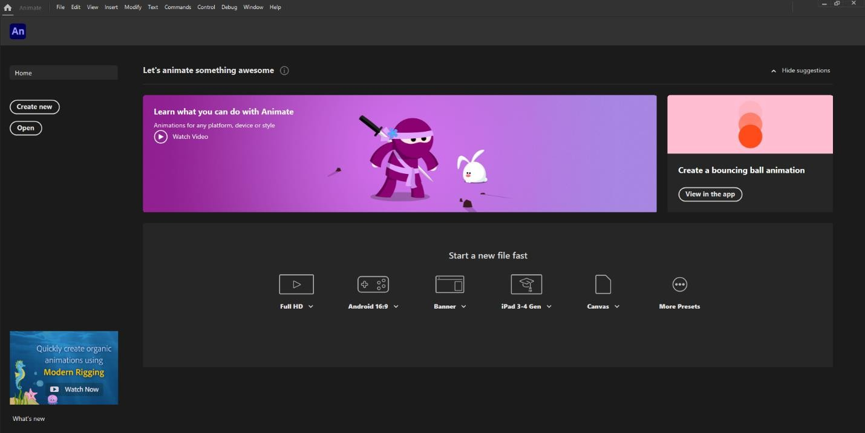

Getting Familiar with the Workspace
- Exploring the Interface:
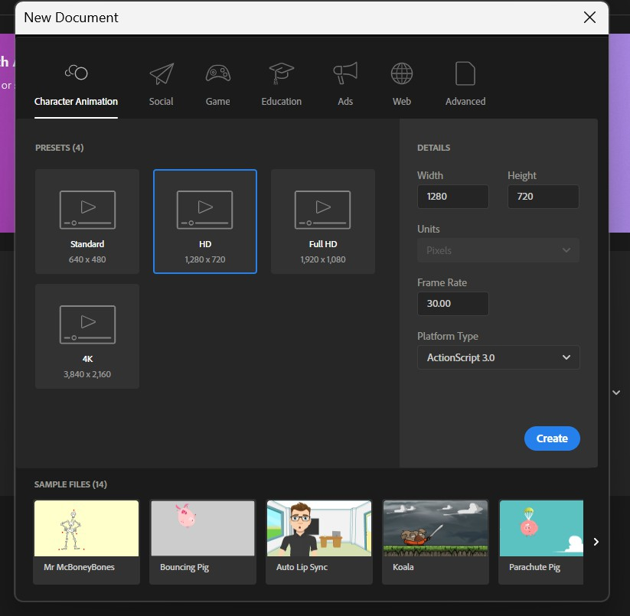
- Open Adobe Animate and create a new project.

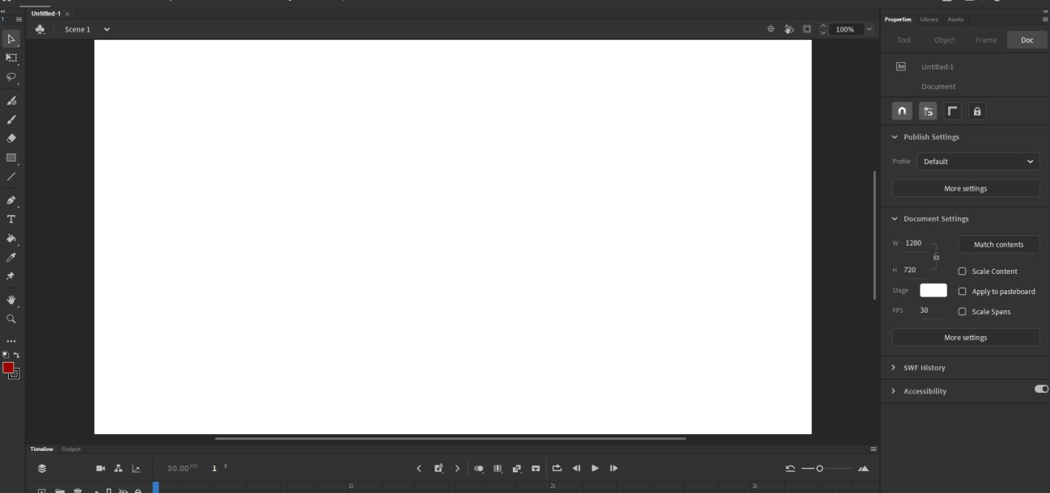
- Take note of the various panels: Toolbar (left side), Properties Panel (right side), Timeline (bottom), and Stage (center).

- Use the Window menu to show or hide different panels as needed.
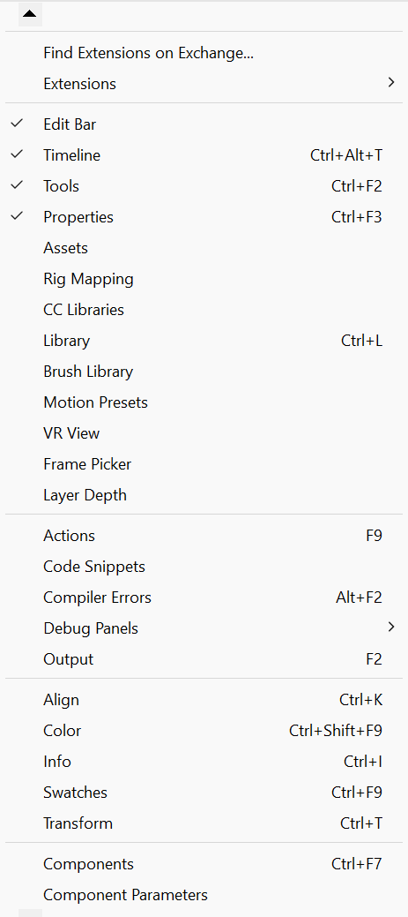

Learning Basic Tools and Functions

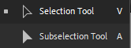
3.1. Selection Tools

- Selection Tool (Black Arrow):
The Selection Tool's purpose is to pick and move items about the level. How to Apply:
  - From the toolbar, choose the Selection Tool (shortcut: V).
  - To choose an object, click on it. The selected object can then be moved, resized, or rotated by dragging it or by using the transform handles.

Sub selection Tool (White Arrow):
The Sub Selection Tool's purpose is to allow users to pick and modify particular points or routes on vector shapes.
How to Apply:
  - From the toolbar, choose the Sub Selection Tool (shortcut: A).
  - To see a vector shape's anchor points, click on it.
- To modify the shape, click and drag any individual handles or anchor points.

Drawing and Shape Tools
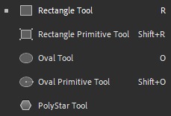
- Brush Tool:

The Brush Tool's purpose is to facilitate freehand drawing. How to Use:
  - From the toolbar, choose the Brush Tool (shortcut: B).
  - From the Properties panel, select the brush size and style.
  - To draw freehand shapes on the stage, click and drag.

Rectangle Tool:
Goal: Drawing rectangular forms is the purpose of the Rectangle Tool. How to Apply:
  - From the toolbar, choose the Rectangle Tool (shortcut: R).
  - To design a rectangle on the stage, click and drag.
  - Press and hold the Shift key to draw an exact square.

Oval Tool:
The Oval Tool's purpose is to design circular or oval forms. How to Use:
  - From the toolbar, choose the Oval Tool (shortcut: O).
  - To draw an ellipse on the stage, click and drag.
  - Press and hold the Shift key to draw an exact circle.

Editing Tools
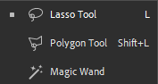
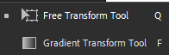
- Free Transform Tool:
The Free Transform Tool's purpose is to rotate, skew, and scale objects. How to Apply:
  - From the toolbar, choose the Free Transform Tool (shortcut: Q).
  - To choose an object, click on it.
  - You may skew, rotate, and resize the object by using the transform handles.

Eraser Tool:

The Eraser Tool's purpose is to remove portions of drawings or objects. How to Apply:
  - From the toolbar, choose the Eraser Tool (shortcut: E).
  - From the Properties panel, select the eraser's size and form.
You can select and move items or drawings on the stage to remove portions of them.

Lasso Tool:
Goal: Objects or portions of objects can be freely selected with the Lasso Tool. How to Apply:
  - From the toolbar, choose the Lasso Tool (shortcut: L).
  - To create a freeform selection around the area you wish to pick, click and drag.
  - To finish the selection, release the mouse button. The selection can then be moved or altered.

Exploring Shape Tween
Creating Shape Tweens:
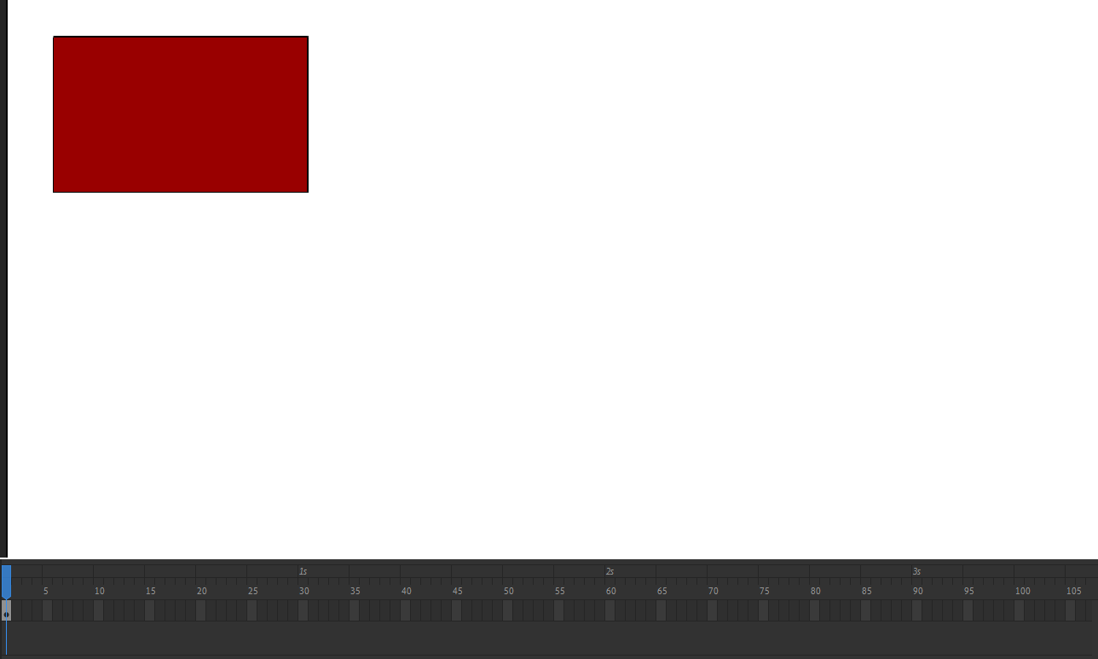
Draw a shape on the first frame of the timelin

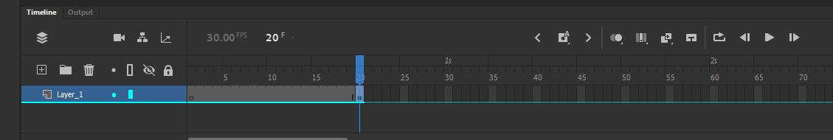
Insert a keyframe at a later point in the timeline.
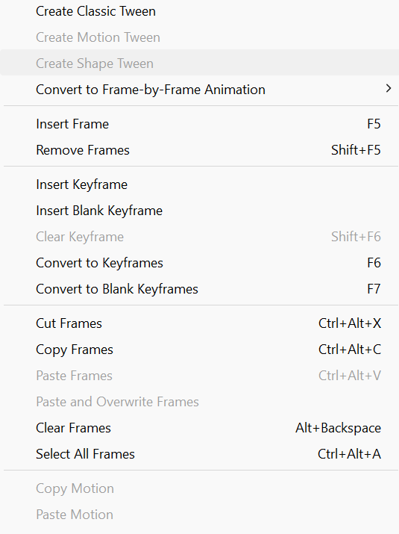

Modify the shape in the new keyframe.

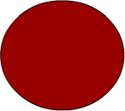

Right-click between the two keyframes and select Create Shape Tween to animate the transformation.
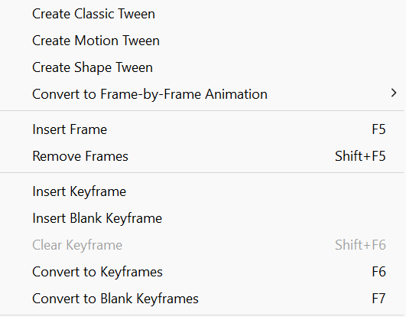

Working with Symbols
Creating Symbols:
Select an object on the stage.
Convert it to a symbol by right-clicking and selecting Convert to Symbol.

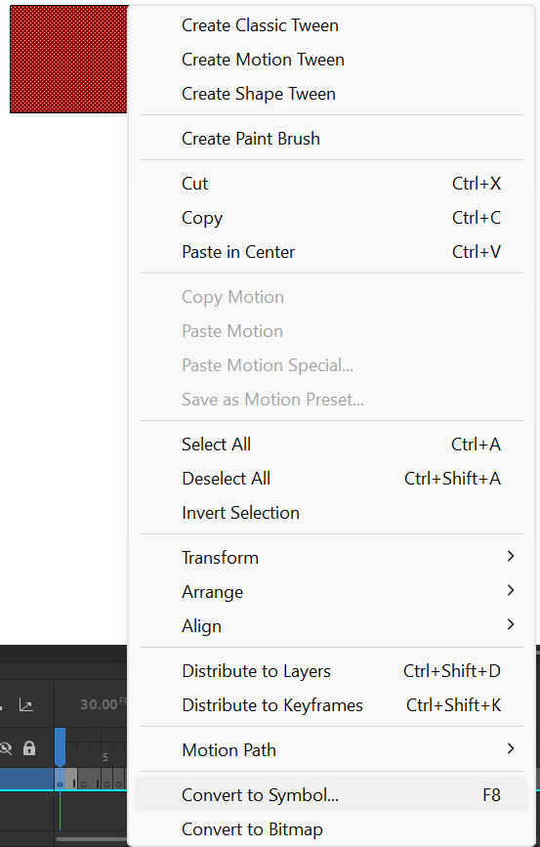

Choose the symbol type (Graphic, Button, or Movie Clip) and give it a name.
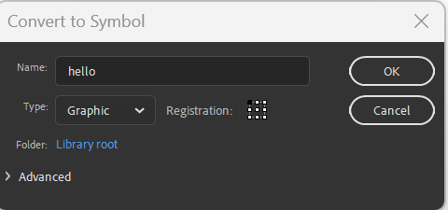

Creating Motion Tweens
Motion Tween Basics:
Create a symbol and place it on the stage.
Right-click on the symbol’s layer in the timeline and select Create Motion Tween.

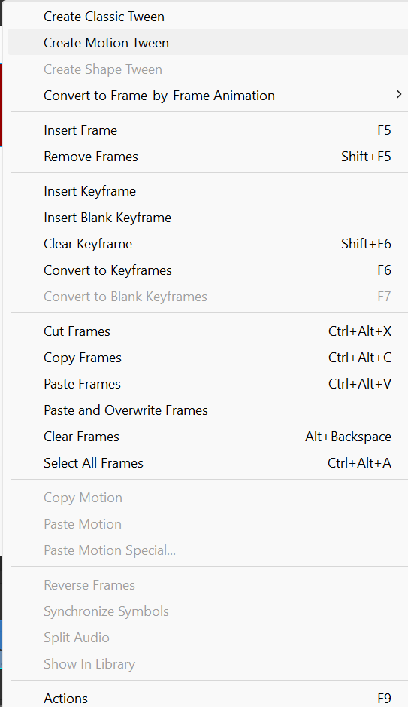

Move the play head to a later point in the timeline and reposition the symbol to create an animation.
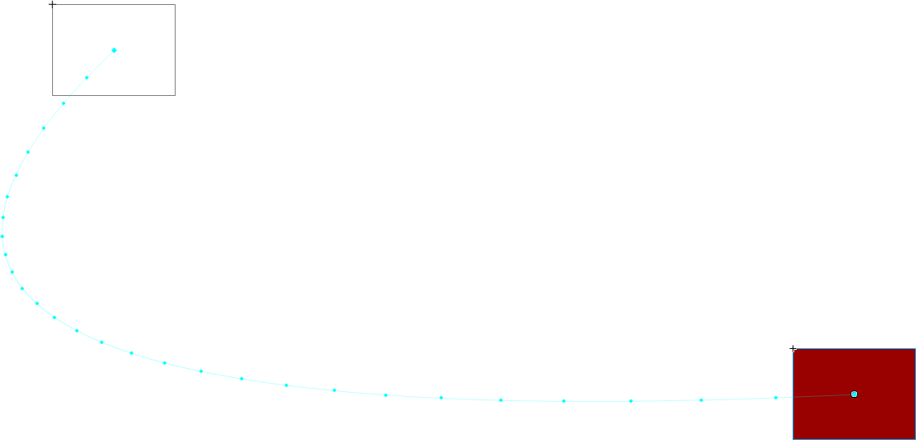

Managing Layers
Layer Organization:
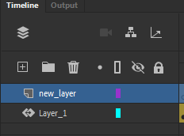
Add new layers by clicking the New Layer button in the timeline panel.
Name layers descriptively (e.g. “Background” & “Character”) for better organization.
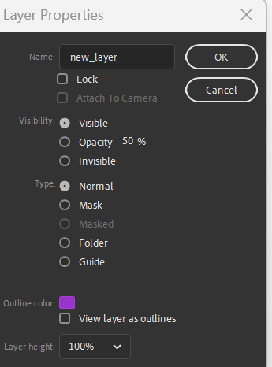
Layer Properties:

Use the visibility (eye) icon to show or hide layers.
Use the lock (padlock) icon to lock layers and prevent accidental edits.

Exporting Animations
Exporting Options:
For video formats, select File > Export > Export Video/Media.
For image sequences or static photos, select File > Export > Export Image. For GIF format, select File > Export > Export Animated GIF.
To access other options such as HTML5 Canvas, WebGL, and Flash, select File > Publish Settings.
Complete Export:
Choose the preferred format and adjust parameters like quality and resolution. To save the animation in the selected format, click Export.

Conclusion
This lab provided a comprehensive introduction to the core features of Adobe Animate, guiding me through the essential aspects of the software. From the initial software setup to navigating the workspace, I gained practical experience with the key tools needed for animation. I learned how to create and modify objects, apply both shape and motion tweens, and manage symbols and layers effectively—crucial skills for any animation project.
Additionally, the lab covered the process of exporting animations, ensuring that I can prepare my work for various platforms and uses. These foundational skills have equipped me to confidently explore more complex digital animation techniques, setting the stage for continued development of my animation expertise.

